TUTORIAL

A tutorial is a self-study activity designed to teach a specific learning outcome of the program.

This is a simple view of the program we are learning to use.

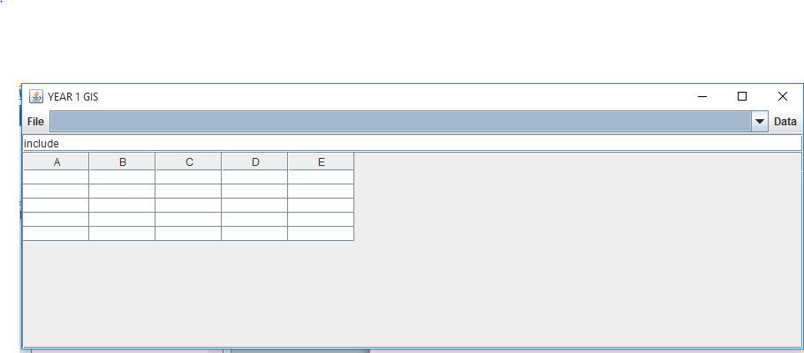

How to open a shapefile

1. The open Shapefile

On clicking the button the following dialogue box from which a shapefile folder is opened.

Then browse the location of the file so as to connect it to the software.

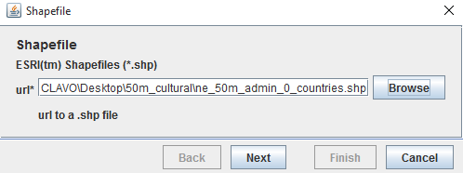

Click on the next button and the following dialogue box is opened

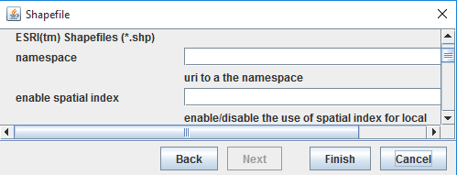

Insert the namespace and enable the spatial index.

**How to create vector data from a CSV**

Click on the file menu and then create shapefile. This then opens a new dialogue box

How to perform coordinate transformation.

1. Click “Open MapContext” under file menu
2. The map context appears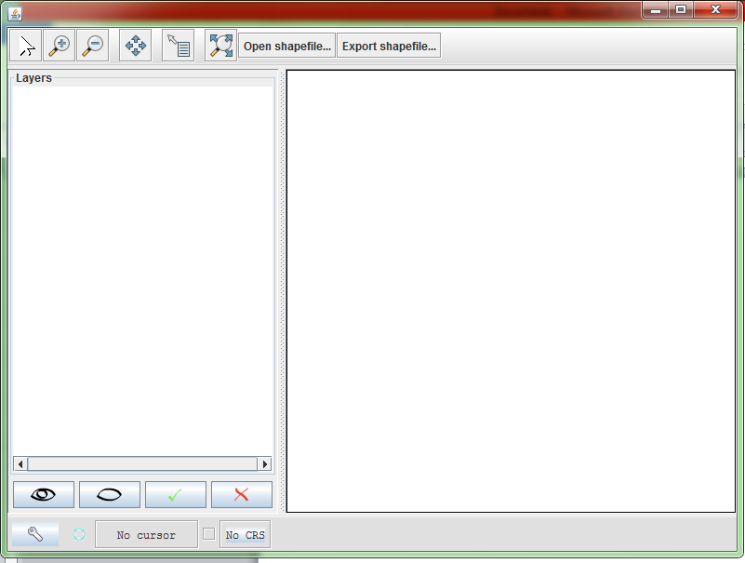
3. Click on open shapefile on the toolbar to add vector data to the map layer
4. A dialog box appears for one to choose the vector data with .shp format.

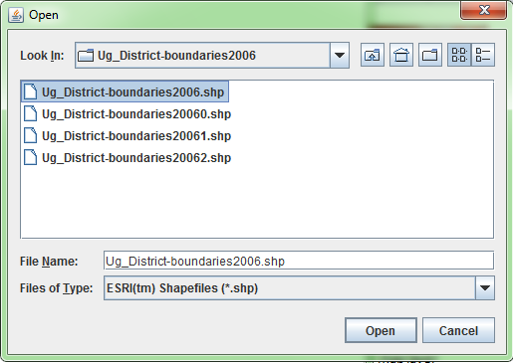

1. Click open and the data will be added to the map layer as shown below

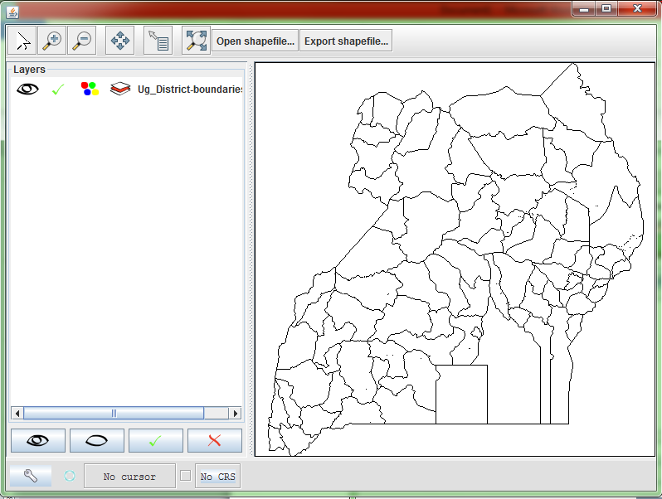

1. Click on “CRS” button to set the coordinate system of the added data

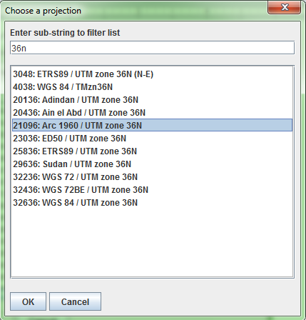

1. Select the coordinate reference system you want to project the data in this case Arc1960 UTM 36N
2. The coordinate system is then displayed on the status bar
3. Click on “Export Shapefile” button on the tool bar to export and save the shapefile with transformed coordinates